

Programming Fundamentals Semester Project Proposal

Project Title: Bus Reservation System (C++)
Name(s) | Mahadi Ur Rehman | Arshan Mirza | Rana Abdullah
Registration Id(s) | 2510382 | 2510376 | 2510386
Program | Bs-BIT  (2nd Semester) | Bs-CMDA  (2nd Semester) | Bs-BIT  (2nd Semester)
Session | 25 Session
Course Name | PROGRAMMING FUNDAMENTALS
Course Instructor | Muhammad Asad Ullah
Task Name | Semester Project Proposal Submission

Contents
Introduction: 3
Objective: 3
Problem Statement: 3
Background Information: 4
Motivation: 4
Scope: 4
Deliverables: 4
Exclusions: 4
Stakeholders: 5
Timeframe Boundaries: 5
Proposed Methodology: 5
Programming Concepts to be Used: 5
Development Process: 5
Tools to be Used 6
Reference Websites: 6
Limitations: 6
Expected Outcomes: 6
Users will be able to: 6
Timeline: 7
Personality Evaluation Results: 7
Name: Mahadi ur Rehman 7
Score Breakdown: 7
Project Contribution: 7
Name: Arshan Mirza 8
Score Breakdown: 8
Project Contribution: 8
Name: Rana Abdullah 9
Score Breakdown: 9
Project Contribution: 10
References: 10

Introduction:
The project titled Bus Reservation System is being developed as part of the Programming Fundamentals course using C++. The purpose of this project is to create a console-based application that allows users to register, log in, view available buses, book seats, and cancel reservations. This system uses the practical implementation of core programming concepts such as variables, loops, arrays, conditionals and functions in C++.

Objective:
The main objective of this project is to:
- Develop a functional Bus Reservation System using C++.
- Apply Programming Fundamentals concepts in a real-world scenario.
- Provide a simple and user-friendly console interface for booking bus seats.
- It helps the user to book, view, delete the seats and further more

Problem Statement:
In many small transport industries, seat reservations are managed manually, which can lead to:
- Seat overbooking
- Data mismanagement
- Human errors
- Difficulty in tracking available seats
- Double booking
- Customer Conflicts
This project aims to solve these issues by creating a computerized reservation system that automatically manages seat availability and user accounts using C++ programming concepts.

Background Information:
Transportation systems are an important part of everyday life. Many bus services require reservation systems to efficiently manage passengers and seat availability. Modern reservation systems are web-based or app-based, but this project focuses on building a simplified console-based version to understand the core programming logic behind such systems. This idea was inspired by real-world bus booking platforms like Aumc Bus System, Daewoo and Faisal Movers.

Motivation:
We chose this project because:
- It represents a real-world application.
- It allows implementation of multiple programming concepts.
- It enhances our problem-solving and logical thinking skills.
This project will strengthen our understanding of Basic Programming Concepts of C++.

Scope:
These are the scope of this project are:

Deliverables:
- A fully working C++ console-based Bus Reservation System.
- Cpp Source Code File.
- Project documentation.

Exclusions:
- No graphical user interfaces.
- No UI interference
- No online or network support.

Stakeholders:
- Project Developer
- Evalutor
- Users

Timeframe Boundaries:
This is a 6-week semester project and will be completed before the final submission deadline.

Proposed Methodology:
The project will follow a structured programming approach using basic Programming Fundamentals concepts in C++.

Programming Concepts to be Used:
- Variables
- Data Types
- If-Else Statements
- Switch Statements
- Loops (for, while, do-while)
- Arrays
- Basic Input/output (cin, cout)
- Simple Validation using Conditions
- Pointer
- User Defined Functions
- File Handling

Development Process:
- Requirement gathering and understanding system flow
- Designing program structure using flowcharts
- Implementing main menu using switch statements
- Creating login and registration system using arrays
- Implementing seat booking and cancellation logic
- Testing the program for errors
- Final documentation

Tools to be Used
- Programming Language: C++
- Compiler: Dev C++
- IDE: Dev C++
- Operating System: Windows 11

Reference Websites:
- W3 Schools
- Geeks for Geeks
- Course lecture notes

Limitations:
- The system will be console-based only.
- No UI interfaces.
- Seat management will be basic using arrays.
- Only limited number of users can register because of fixed array size.
- Time constraints due to academic schedule.

Expected Outcomes:
By the end of the project:
- A fully functional console-based Bus Reservation System will be developed.

Users will be able to:
- Register
- Login
- View available buses
- Book seats
- Cancel bookings

Timeline:
Week 1–2 | Research and Requirement Analysis
Week 3 | Program Structure Design
Week 4–5 | Coding and Testing
Week 6 | Debugging and Documentation
Final Week | Submission and Presentation

Personality Evaluation Results:

Name: Mahadi ur Rehman
Primary Type: The Analyst 🔬
Suggested Role: QA Engineer / Debugger

Score Breakdown:
- The Architect: 2/12
- The Builder: 1/12
- The Analyst: 5/12
- The Connector: 4/12
Key Traits: Detail-oriented, Spots what others miss, Tests edge cases, Quality-focused

Project Contribution:
Own test cases, validate all inputs, hunt edge cases, and produce the user manual. Your sign-off means the project is ready.
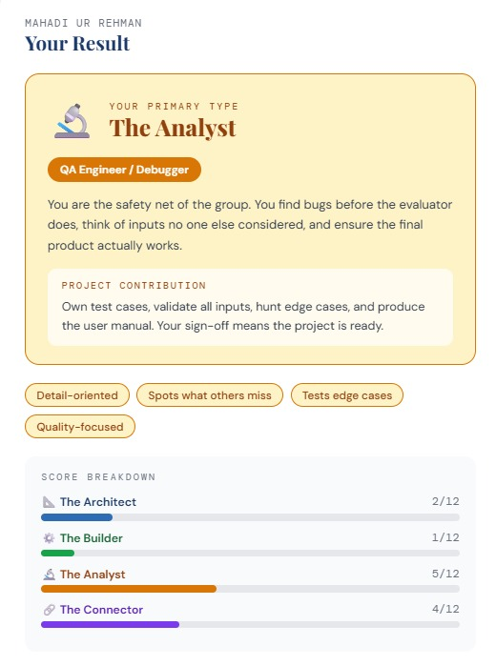

Name: Arshan Mirza
Primary Type: The Connector 🔗
Suggested Role: Project Coordinator / Presenter

Score Breakdown:
- The Architect: 0/12
- The Builder: 2/12
- The Analyst: 2/12
- The Connector: 8/12
Key Traits: Natural communicator, keeps team aligned, Great at explaining ideas, Deadline-aware

Project Contribution:
Manage milestone deadlines, write documentation & comments, lead the Week 14 presentation, and be the group's single point of contact with the instructor.
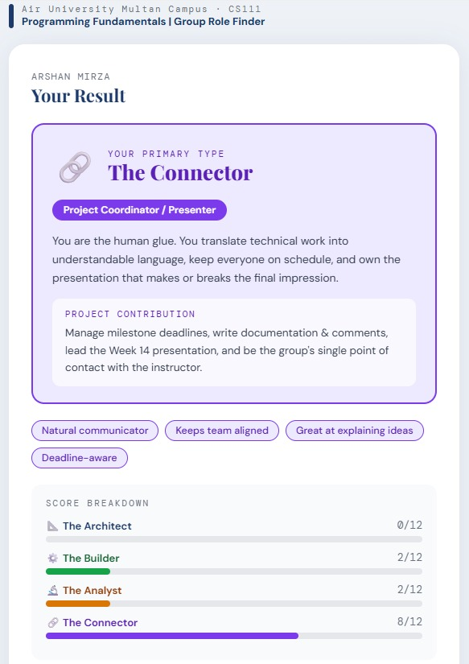

Name: Rana Abdullah
Primary Type: The Analyst 🔬
Suggested Role: QA Engineer / Debugger

Score Breakdown:
- The Architect: 1/12
- The Builder: 2/12
- The Analyst: 7/12
- The Connector: 2/12
Key Traits: Detail-oriented, Spots what others miss, Tests edge cases, Quality-focused

Project Contribution:
Own test cases, validate all inputs, hunt edge cases, and produce the user manual. Your sign-off means the project is ready.
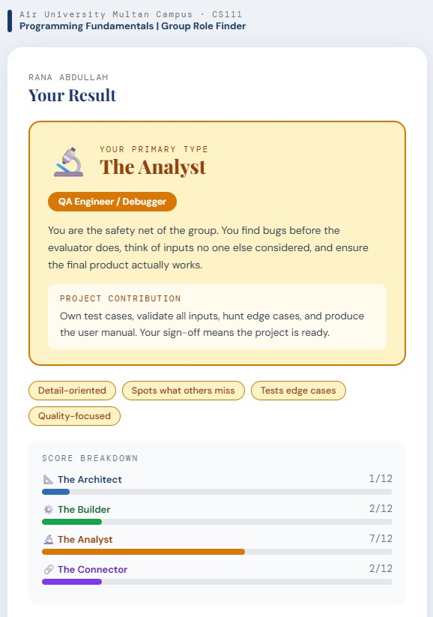

References:
- C++ Programming by Harry.H. Chaudhary
- C++ Basics for New Programmers by William E. Clark
- Geeks for Geeks
- W3Schools
- Course Material and Lecture Note

